**1/9/2022**

**Relational Database**

* Data is stored in tables
* Similar data is in each table
* Tables relate to each other

**Entity**

* Something you want to store data about (e.g. customer, order, etc.)

**Attributes(column/field)**

* Describes the entity (e.g. Last name, First name, etc.)

**Atomic attributes**

* smallest form

**Composite Attributes**

* can be broken down into more atomic attributes

**Stored attributes**

* store everything

**Derived attributes**

* calculated from other stored attributes

|  |  |
| --- | --- |
| **Atomic** | **Composite** |
| **Pros** | |
| Better searches | Less attributes |
| Display as various formats | Already formatted |

**ATOMIC IS BETTER**

|  |  |
| --- | --- |
| **Stored** | **Derived** |
| **Pros** | |
| Ready to go | Less storage |
| Cons | |
| Using more storage | More complicated |

**Stored vs Derived = winner is inconclusive. Depends on case use. Instructor preference is** STORED.

6/9/2022

**Primary Key**

* attribute(s) that uniquely identify one record (e.g. Item Number)
* ~99.99% of Primary keys contain 3 words.
  + ID
  + Number
  + Code

**Technical Key**

* attribute solely for the purpose of acting as the primary key(e.g StudentID)

**Concatenated Composite Key**

* a primary key made up of more than one attribute

**Foreign Key**

* primary key of one entity that appears as an attribute of another entity, relating the two tables together

RULES

* Primary Key – the values MUST be unique
* Foreign Key – the values MUST exist in the primary key of the related table

**Relationships**

3 Kinds of Relationships

**One-to-Many**

* one record in one table relates to many records in the other

**One-to-One**

* one record in one table relates to only one record in the other
* it is relatively rare
* e.g one parking stall belongs to one staff member, and a staff member is only allowed one parking stall

**Many to Many**

* impossible
* one record in one table relates to many records in the other and vice versa

**Parent entity**

* one side of the relationship
* primary key in the relationship
* the one that does not have a foreign key, or the primary key being used as foreign key

**Child entity**

* many side of the relationship
* foreign key in the relationship
* can have child entities also

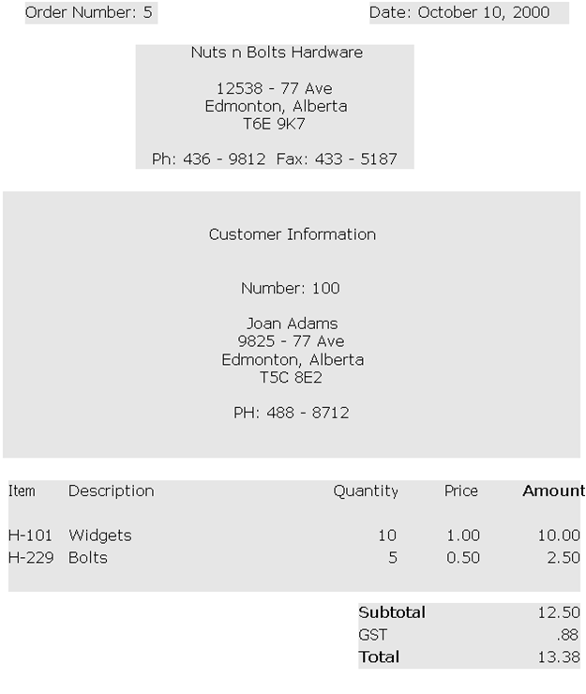**Entity-Relationship Diagram(ERD)**

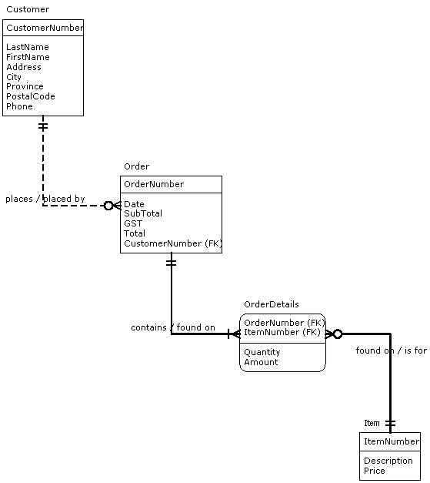

<- Parent

^-Normalization Process

**Non-Identifying Relationship (dashed line)**

* Foreign key in the relationship is NOT part of the primary key

Identifying Relationship (solid line)

* Foreign key is part of the primary key in the child entity

**Notation**

|  |  |  |
| --- | --- | --- |
| Cardinality | Symbol | Definition |
|  |  |  |
| To one |  | One instance of an entity is related to one instance of another entity. For example marriage: one instance of the husband entity is related to one instance of the wife entity. |
| To zero or one |  | One instance of an entity is related to zero or one instance of another entity. For example assigning parking stalls: one instance of the employee entity is related to one instance of the parking stall entity. Employees who do not drive to work do not participate in the relationship, therefore, not all instances of the employee entity would be related to a parking stall entity. |
| To one or many |  | One instance of an entity is related to one or many instances of another entity. For example time cards for hourly employees: one instance of the employee entity is related to one or more instances of the time card entity. |
| To zero, one or many |  | One instance of an entity is related to zero, one or many instances of another entity. For example employees assigned to projects: one instance of the employee entity is related to zero, one or many instances of the project entity. |
| To many |  | One instance of an entity is related to many instances of another entity. For example students enrolled in courses: one instance of the course entity is related to many instances of the student entity. |